Smart Views for Merged Courses
If your Blackboard courses are merged, you might want to set up “Smart Views” to filter out the different sections in your Grade Center. This is particularly helpful for reporting midterm and final grades because you can view one section of students at a time.
- In your merged course, go to Grade Center > Full Grade Center.
- At the top, click the Manage drop-down menu and select Smart Views.
- By default, the “Assignments” and “Tests” are marked as Favorites and displayed in the Grade Center menu on the left, below the “Full Grade Center” link. You can deselect those two by clicking the green star in the “Add as Favorite” column.
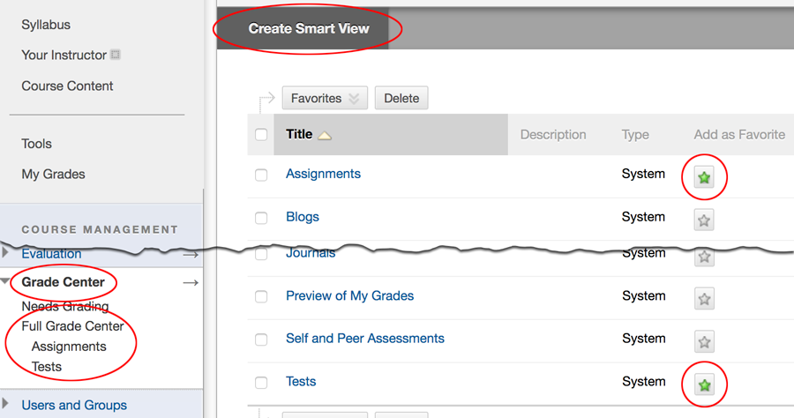
- Click the Create Smart View button at the top.
  - For the Name, type the section information and CRN (e.g., “A 20123” or “WW1 20123”).
  - Click the Add as Favorite checkbox so it will show up in the Grade Center menu on the left, making it easy to use.
  - For the Type of View, switch the radio button to Custom Build a query based on user criteria.
  - For the User Criteria, select Child Course ID.
  - For the Condition, select Contains.
  - In the Value textbox, type in the section’s full Course ID (displayed in the Child Course ID column in the Full Grade Center). It should be something like 202202_D_ENG101_20123 –> Termcode_Delivery_CourseNumber_CRN. Make sure it does not include any spaces.
  - Switch the Filter Results drop-down menu to All Columns. Click Submit.
Optionally, if you hide the Grade Center rows of students who dropped or withdrew, you can add additional criteria after step f so they’re hidden in the Smart View as well. Click the Add User Criteria button, switch the User Criteria to Shown/Hidden, and select Shown.
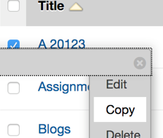
To make the next Smart View, either Repeat Step 4 above or use the shortcut below.
- Click the drop-down menu to the right of the Smart View you just made and choose Copy.
- Change the Name and the Value Course ID for the new CRN.
- Click Submit.
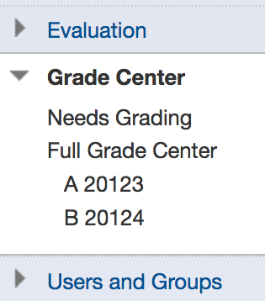
After you have the Smart Views made, you can click on them in the Grade Center menu on the left to make sure they work. They should filter the rows that are displayed, so you only see the students in that CRN.
To view all of the students, click the Full Grade Center link.

Need Help?
Contact one of our instructional designers.

